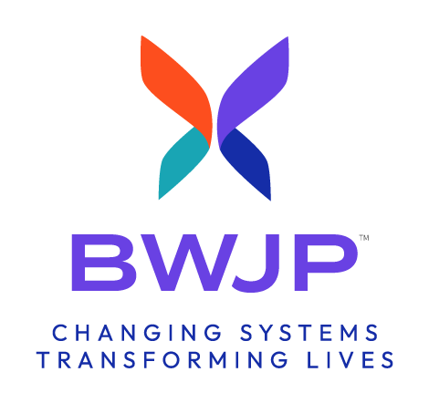

ESPOC: Logic Model Template Samples

SAMPLE ONE- Chart Logic Model Template

Goal:
Objective(s):
Problem/Challenge #1:

INPUTS & RESOURCES | PROPOSED ACTIVITIES | SHORT TERM OUTCOMES  (6 – 24 MONTHS) | LONGER TERM OUTCOMES  (2-5 YEARS)

SAMPLE TWO- Logic Model Template

Goal:

Objective(s):

Problem / Challenge #1
_____________________________________________

Inputs & Resources
•
•
•

Proposed Activities
•
•
•

Short-Term Outcomes (6–24 Months)
•
•
•

Long-Term Outcomes (2–5 Years)
•
•
•

